Hydraulics and Pneumatics Lab Experiments

1. Hydraulics
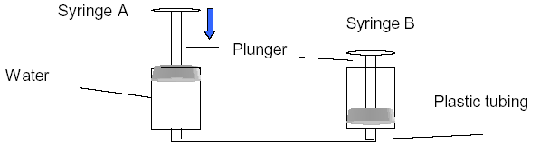
What happened? Explain why using scientific terms.

If you changed the size of the syringes what happened? Why? If you didn’t do this, what do you think would happen and explain your reasoning using scientific terms.

2. Pneumatics
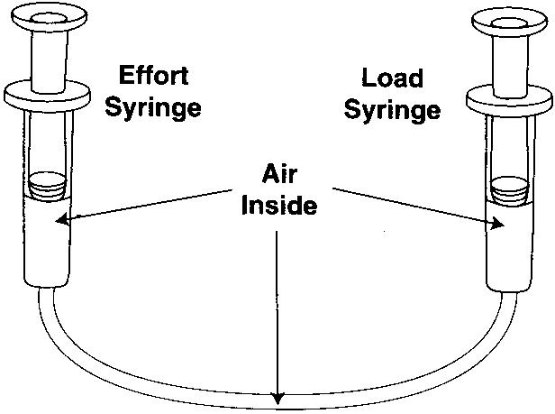
What happened? Explain why using scientific terms.

If you changed the size of the syringes what happened? Why? If you didn’t do this, what do you think would happen and explain your reasoning using scientific terms.

3. Pressure

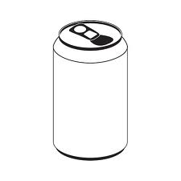

What happened? Explain why using scientific terms.

