Lesson 4: Pythagorean Theorem

Activity:

Explain the diagram below:

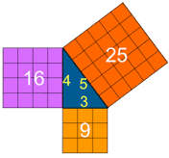
A₁ + A₂ = A₃

How is this diagram related to the Pythagorean Theorem?
a² + b² = c²

Notes:

Write the following in your notebook:
- Key ideas page 65
- Key ideas page 70
- Example 1 and 2 page 63
- Example 1 and 2 page 68-69

Practice:

Textbook Page 65 #4, 7, 8, 12
Page 70 #4, 6, 7, 10

Quiz:

When you have completed the lesson and feel comfortable that you understand the concepts ask your teacher for the Lesson 4 quiz.

Quiz 4: Pythagorean Theorem
Attempt 1:
Attempt 2:
Attempt 3:

